Budgeting App Proposal

# Introduction

## Motivation:

As a college student only working a part-time job on weekends, saving and spending money has been something that I have had to do strategically. While I am not in the worst financial position currently, budgeting is something that could personally benefit me—or at the very least make my life easier. Budgeting would allow me to be precisely aware of how much money I am currently spending, how much money I need to save, and how much money I need to spend on certain necessities such as food and rent. Ultimately, this will allow me to save money in the long run and spend money with reassurance.

Additionally, budgeting apps are already commonplace among mobile app stores. While I do not strive to make the best budgeting application by any means, creating my own application is a way to ensure that my budgeting is private and secure from external entities that seek to use such data for their own gain.

## Proposed System

I am proposing an Android application that allows its user to create budgets, log financial transactions, planning for expenses, and track spending. I will aim to create these features for daily, weekly and monthly time frame.

# Structured Analysis

## Use Case Diagram

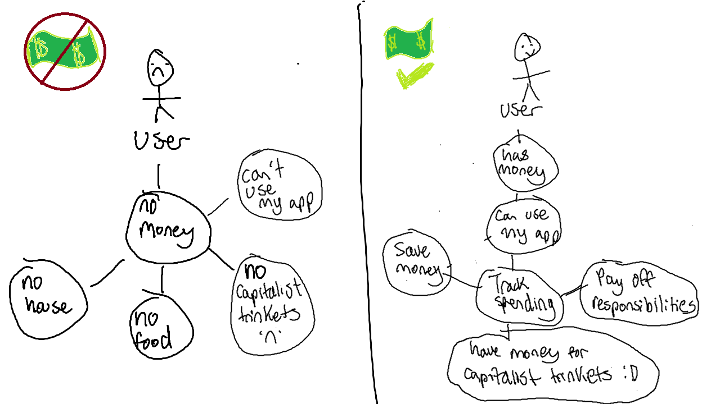

# System Design

## User Interface

* + 1. The user interface will contain a navigation bar to allow the user to change between a home page, calendar view, weekly page, and monthly page.
    2. On the home page, the user can log transactions by time and date, with the default time and date being the exact time the transaction was logged. The user will also be able to see the log of transactions made that day and the date can be manually changed. This page will also feature the daily budget, which will by default be the average of the weekly budget per day.
    3. On the calendar page, the user will be able to choose days in the future to schedule any necessary payments such as rent. These scheduled costs will show up in the daily, weekly, and monthly budgets and be included in the respective budgets. The user can also add their income as scheduled events that will be incorporated in the budgets.
    4. The weekly page will allow the user to view and manually set their budget for any selected week (Sunday to Saturday) with the default week being the current week. Any scheduled payments will be listed in order on the page. The default budget will be the average of the monthly budget per week (with incomplete weeks being counted as a fraction of a week).
    5. The monthly page will allow the user to view and set their budget for any selected month (first day to the last day of the month) with the default month shown being the current month. Any scheduled payments will be listed in order on the page

## Entity Relationship Diagram

## 

## Class Diagram (Will Probably Change)

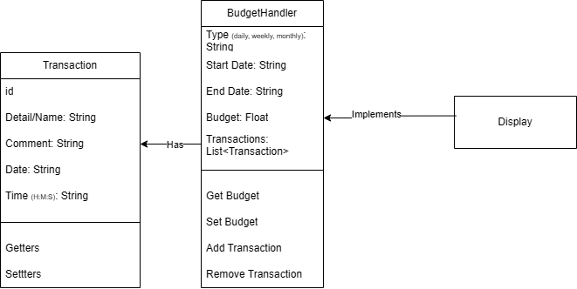

## Application Architecture Diagram

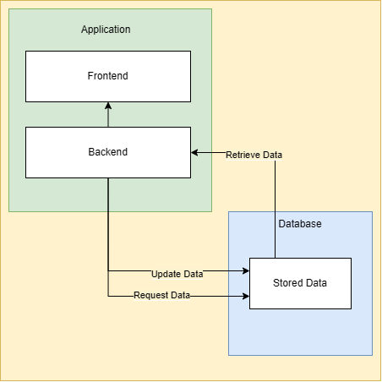

# Implementation

## Programming Languages

* + 1. This application will be built on Java and use SQL for the database. The Java.time package will be used as attributes in some classes.

## IDEs, Tools, and Technologies

* + 1. Android Studio will be used for the development of the application (hence the use of Java). MySQL will be used to create and update the database.

## Milestones and Scheduling

* + 1. Create main application functions (3 weeks)
       1. BudgetHandler
       2. Calendar View
       3. Scheduling budget events
       4. Home Page
       5. Transactions
       6. Weekly Page
       7. Monthly Page
    2. Create database and local server (1 week)